Gliwice, 28.09.2019r.

Laboratorium Programowania Komputerów 2

Temat: Gra Copter Game

Autor: Wojciech Pietrzak
Kierunek: Informatyka
sem VI
grupa dziekańska BDIS
Prowadzący: mgr inż. Grzegorz Wojciech Kwiatkowski

1. Temat
Moim zadaniem było wykonanie programu z wykorzystaniem biblioteki OpenGL w postaci gry: Copter Game. Program został napisany w języku C.

2. Analiza, projektowanie
2.1 struktury danych
Już przy projektowaniu założyłem, że struktury jakie mi będą potrzebne to:

typedef struct HELICOPTER {
int x;
int y;
int radius;
int life;
int startingLife;
}Helicopter;

typedef struct OBSTACLE {
int verticies[8];
}Obstacle;

typedef struct BULLET
{
int x;
int y;
int radius;
float colorR;
float colorG;
float colorB;
int speed;
int running;
}Bullet;

2.2. Analiza problemu, podstawy teoretyczne
Do obliczenia odległości między punktami kolizji (Obstacles) oraz strzałami (Bullet) oraz playerem (Helicopter) wykorzystałem twierdzenie Pitagorasa:

float getDistance(int x1, int x2, int y1, int y2)
{
int dx = x2 - x1;
int dy = y2 - y1;
int ddx = dx * dx;
int ddy = dy * dy;
return sqrt(ddy + ddx);
}

3. Specyfikacja zewnętrzna - Instrukcja obsługi oraz zachowanie programu.
Po uruchomieniu pliku OpenGL.exe włącza nam się okno graficzne ze światem gry oraz w drugim oknie konsola, w której zapisywana jest ilość zdobytych punktów po zakończeniu gry, najlepszy wynik oraz na bierząco wyskakuje infornacja o przegranej czy stracinym życiu. Jest ich trzy. Za trzecim zderzeniem z przeszkodą, gra się kończy, a informacja jest wyświetlana na konsoli. Przy pierwszym i drugim zderzeniu player zmienia na moment swój kolor domyślny biały na czewony (przy utracie życia). To również jest wyświetlane na konsoli. (ilość pozostałych żyć). Wygląda to w następujścy sposób:

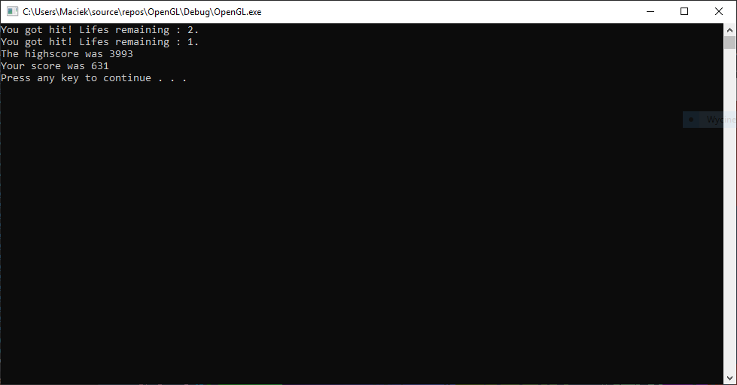
A tak wygląda świat gry:

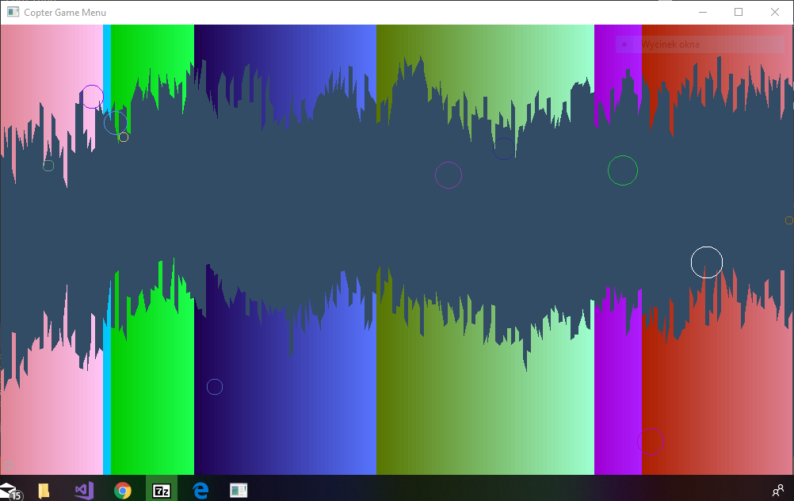
Gracz oznaczony jest kolorem białym, natomiast pozostałe kule są strzałami.

Po przejściu graczem z wykorzystaniem strzałek (góra, dół), pojawia nam się nowy ekran, kule pojawiają się częściej i łatwiej jest stacić życie. Strzałka w lewo "hamuje" gracza na moment, aby uniknąć zderzenia.

4. Specyfikacja wewnętrzna

Użyte zmienne:

#define WINDOW_WIDTH 1000
#define WINDOW_HEIGHT 600
#define TERRAIN_WIDTH 200

// Constants
const GLint WIDTH = WINDOW_WIDTH;
const GLint HEIGHT = WINDOW_HEIGHT;
const GLint NUMBER_OF_OBSTICLES = TERRAIN_WIDTH;
const GLfloat OBSTICLE_WIDTH = WINDOW_WIDTH / TERRAIN_WIDTH;

// Game variables
int HIGHSCORE = 0;
int SCORE = 0;
int COLLISION_TIMEOUT = 0; //czas jaki Player jest nietykalny po utracie życia
int HARDNESS = 3000;

// Color variables
float colorR = 0.01;
float colorG = 0.01;
float colorB = 0.01;

// Player
int speed = 3; //prędkość z jaką porusza się Player

Użyte funkcje:

// Setup
void Setup();
void SetupOpenGL();
Obstacle GenerateUpperObstacle(int X, int Y); // zwraca element górnej krawędzi
Obstacle GenerateBottomObstacle(int X, int Y); // zwraca element dolnej krawędzi
void GenerateTerrain();

// Move functions
void MoveUp();
void MoveDown();
void MoveLeft();
void MoveRight();

// Detect input
void GetUserInput();
void KeyInput();

// Highscore manipulation
void LoadScore();
void OverwriteScore();

// Drawing
void DrawTerrain();
void DrawObstacle(Obstacle obstacle);
void DrawPlayer();
void DrawCircle(float cx, float cy, float r, int num_segments);
void DrawBullets();

// MainLoop
void MainLoop();
void EndGame();

// Collisions
void CheckCollisions();
void CheckPlayer_TerrainCollisions();
void CheckPlayer_BulletCollisions();
void CollisionOccured();

// Next level
void CheckIfNextLevel();
void NextLevel();

// Terrain movement
void MoveTerrain();

// Bullets
Bullet MakeBullet(int x, int y); //zwraca strukturę bullet
void GenerateBullets();
void WakeBullets();
void MoveBullets();

// Others
int getRandom(int bottomBound, int upperBound);
float getDistance(int x1, int x2, int y1, int y2);

4. Kod źródłowy programu

// Disable warnings
#define _CRT_SECURE_NO_WARNINGS

// Includes
#include <stdio.h>
#include <stdlib.h>
#include <time.h>
#include <math.h>

// GLEW
#define GLEW_STATIC
#include <GL/glew.h>

// GLFW
#include <GLFW/glfw3.h>

#define WINDOW_WIDTH 1000
#define WINDOW_HEIGHT 600
#define TERRAIN_WIDTH 200

// Constants
const GLint WIDTH = WINDOW_WIDTH;
const GLint HEIGHT = WINDOW_HEIGHT;
const GLint NUMBER_OF_OBSTICLES = TERRAIN_WIDTH;
const GLfloat OBSTICLE_WIDTH = WINDOW_WIDTH / TERRAIN_WIDTH;

// Game variables
int HIGHSCORE = 0;
int SCORE = 0;
int COLLISION_TIMEOUT = 0;
int HARDNESS = 3000;

// Color variables
float colorR = 0.01;
float colorG = 0.01;
float colorB = 0.01;

// Structure
enum STATE { TITLE, PLAYING, GAMEOVER };
enum MYKEYS { KEY_UP, KEY_DOWN };

typedef struct HELICOPTER {
int x;
int y;
int radius;
int life;
int startingLife;
}Helicopter;

typedef struct OBSTACLE {
int verticies[8];
}Obstacle;

typedef struct BULLET
{
int x;
int y;
int radius;
float colorR;
float colorG;
float colorB;
int speed;
int running;
}Bullet;

// Game structures
Obstacle UpperTerrain[TERRAIN_WIDTH];
Obstacle BottomTerrain[TERRAIN_WIDTH];
Bullet Bullets[TERRAIN_WIDTH];

// Player
Helicopter Player;
int speed = 3;
void PrintPlayerPosition()
{
printf("X : %d Y : %d\n", Player.x, Player.y);
}

// Window structures
GLFWwindow * MenuWindow;

// Setup
void Setup();
void SetupOpenGL();
Obstacle GenerateUpperObstacle(int X, int Y);
Obstacle GenerateBottomObstacle(int X, int Y);
void GenerateTerrain();

// Move functions
void MoveUp();
void MoveDown();
void MoveLeft();
void MoveRight();

// Detect input
void GetUserInput();
void KeyInput();

// Highscore manipulation
void LoadScore();
void OverwriteScore();

// Drawing
void DrawTerrain();
void DrawObstacle(Obstacle obstacle);
void DrawPlayer();
void DrawCircle(float cx, float cy, float r, int num_segments);
void DrawBullets();

// MainLoop
void MainLoop();
void EndGame();

// Collisions
void CheckCollisions();
void CheckPlayer_TerrainCollisions();
void CheckPlayer_BulletCollisions();
void CollisionOccured();

// Next level
void CheckIfNextLevel();
void NextLevel();

// Terrain movement
void MoveTerrain();

// Bullets
Bullet MakeBullet(int x, int y);
void GenerateBullets();
void WakeBullets();
void MoveBullets();

// Others
int getRandom(int bottomBound, int upperBound);
float getDistance(int x1, int x2, int y1, int y2);

int main()
{
Setup();
SetupOpenGL();
GenerateTerrain();
GenerateBullets();
MainLoop();
}

// Setup
void Setup()
{
srand(time(NULL));
Player.x = 0;
Player.y = HEIGHT / 2;
Player.radius = 20;
Player.startingLife = 3;
Player.life = Player.startingLife;
}
void SetupOpenGL()
{
//Setting up GLFW.
glfwInit();

//Creating the main menu window.
MenuWindow = glfwCreateWindow(WIDTH, HEIGHT, "Copter Game Menu", NULL, NULL);

//Check successful window creation.
if (MenuWindow == NULL)
{
glfwTerminate();
return EXIT_FAILURE;
}

//Setting focus.
glfwMakeContextCurrent(MenuWindow);

//Enabling GLEW new functionality.
glewExperimental = GL_TRUE;

//Initializing GLEW.
if (glewInit() != GLEW_OK)
{
glfwTerminate();
return EXIT_FAILURE;
}

//Data initialization.
{
int x; int y;
glfwGetFramebufferSize(MenuWindow, &x, &y);
}

//Some other OpenGL options.
glOrtho(0.f, WINDOW_WIDTH, WINDOW_HEIGHT, 0.f, 0.f, 1.f);
glfwSetInputMode(MenuWindow, GLFW_CURSOR, GLFW_CURSOR_HIDDEN);
}
Obstacle GenerateUpperObstacle(int X, int Y)
{
Obstacle obstacle;
obstacle.verticies[0] = X - OBSTICLE_WIDTH / 2;
obstacle.verticies[1] = Y;
obstacle.verticies[2] = X + OBSTICLE_WIDTH / 2;
obstacle.verticies[3] = Y;
obstacle.verticies[4] = X + OBSTICLE_WIDTH / 2;
obstacle.verticies[5] = 0;
obstacle.verticies[6] = X - OBSTICLE_WIDTH / 2;
obstacle.verticies[7] = 0;
return obstacle;
}
Obstacle GenerateBottomObstacle(int X, int Y)
{
Obstacle obstacle;
obstacle.verticies[0] = X - OBSTICLE_WIDTH / 2;
obstacle.verticies[1] = Y;
obstacle.verticies[2] = X + OBSTICLE_WIDTH / 2;
obstacle.verticies[3] = Y;
obstacle.verticies[4] = X + OBSTICLE_WIDTH / 2;
obstacle.verticies[5] = HEIGHT;
obstacle.verticies[6] = X - OBSTICLE_WIDTH / 2;
obstacle.verticies[7] = HEIGHT;
return obstacle;
}
void GenerateTerrain()
{
int index;
int lastUpperValue = 100;
int lastBottomValue = HEIGHT - 100;
int random;
for (index = 0; index < NUMBER_OF_OBSTICLES; index++)
{

float XPosition = (index + 0.5) * OBSTICLE_WIDTH;
UpperTerrain[index] = GenerateUpperObstacle(XPosition, lastUpperValue);
BottomTerrain[index] = GenerateBottomObstacle(XPosition, lastBottomValue);
random = getRandom(-10, 10);
lastBottomValue += random;
lastUpperValue += random;
if (lastBottomValue > HEIGHT)
{
lastBottomValue -= 2 * random;
lastUpperValue -= 2 * random;
}
if (lastUpperValue < 0)
{
lastBottomValue -= 2 * random;
lastUpperValue -= 2 * random;
}
}
}

// Move functions
void MoveUp()
{
Player.y -= speed;
}
void MoveDown()
{
Player.y += speed;
}
void MoveLeft()
{
Player.x -= speed;
}
void MoveRight()
{
Player.x += speed;
}

// Detect input
void GetUserInput()
{
// Move up
if (glfwGetKey(MenuWindow, GLFW_KEY_UP) == GLFW_PRESS) {
MoveUp();
}
// Move down
if (glfwGetKey(MenuWindow, GLFW_KEY_DOWN) == GLFW_PRESS) {
MoveDown();
}
// Strafe right
if (glfwGetKey(MenuWindow, GLFW_KEY_RIGHT) == GLFW_PRESS) {
Player.x++;
}
// Strafe left
if (glfwGetKey(MenuWindow, GLFW_KEY_LEFT) == GLFW_PRESS) {
Player.x-=2;
}
}
void KeyInput()
{

}

// Highscore manipulation
void LoadScore()
{
FILE *filescore;
int tempscore;
filescore = fopen("highscore.dat", "r");
if (filescore == NULL)
HIGHSCORE = 0;
else
{
fscanf(filescore, "%d", &tempscore);
HIGHSCORE = tempscore;
fclose(filescore);
}
return;
}
void OverwriteScore()
{
FILE *filescore;
filescore = fopen("highscore.dat", "w");
if (SCORE > HIGHSCORE)
fprintf(filescore, "%d", SCORE);
else
fprintf(filescore, "%d", HIGHSCORE);
fclose(filescore);
return;
}

// Drawing
void DrawTerrain()
{
int index;
for (index = 0; index < NUMBER_OF_OBSTICLES; index++)
{
glColor3f(colorR, colorG, colorB);
colorR += 1.0f / NUMBER_OF_OBSTICLES;
colorG += 2.0f / NUMBER_OF_OBSTICLES;
colorB += 3.0f / NUMBER_OF_OBSTICLES;
if (colorR > 1.0f)
colorR = 0;
if (colorG > 1.0f)
colorG = 0;
if (colorB > 1.0f)
colorB = 0;
DrawObstacle(UpperTerrain[index]);
DrawObstacle(BottomTerrain[index]);
}
}
void DrawObstacle(Obstacle obstacle)
{
glEnableClientState(GL_VERTEX_ARRAY);
glVertexPointer(2, GL_INT, 0, obstacle.verticies);
glDrawArrays(GL_POLYGON, 0, 4);
glDisableClientState(GL_VERTEX_ARRAY);
}
void DrawPlayer()
{
if (COLLISION_TIMEOUT > 0 && COLLISION_TIMEOUT % 10 < 5)
{
glColor3f(0.9, 0.3, 0.3);
DrawCircle(Player.x, Player.y, Player.radius, 30);
}
else
{
glColor3f(1.0, 1.0, 1.0);
DrawCircle(Player.x, Player.y, Player.radius, 30);
}
}
void DrawCircle(float cx, float cy, float r, int num_segments)
{
glBegin(GL_LINE_LOOP);
for (int ii = 0; ii < num_segments; ii++) {
float theta = 2.0f * 3.1415926f * ii / num_segments;//get the current angle
float x = r * cosf(theta);//calculate the x component
float y = r * sinf(theta);//calculate the y component
glVertex2f(x + cx, y + cy);//output vertex
}
glEnd();
}
void DrawBullets()
{
int index;
for (index = 0; index < NUMBER_OF_OBSTICLES; index++)
{
if (Bullets[index].running == 1)
{
glColor3f(Bullets[index].colorR, Bullets[index].colorG, Bullets[index].colorB);
DrawCircle(Bullets[index].x, Bullets[index].y, Bullets[index].radius, 12);
}
}
}

// MainLoop
void MainLoop()
{
while (!glfwWindowShouldClose(MenuWindow))
{
//Clearing the event pool.
glfwPollEvents();

//Clearing the view.
{
glClearColor(0.2, 0.3, 0.4, 1.0);
glClear(GL_COLOR_BUFFER_BIT);
}

//Draw OpenGL stuff.
{
DrawTerrain();
DrawPlayer();
}

//Player.
{
MoveRight();
GetUserInput();
}

//Terrain
{

}

//Bullets
WakeBullets();
MoveBullets();
DrawBullets();

//Swap front and back buffers.
glfwSwapBuffers(MenuWindow);

//Check for player colissions.
if (COLLISION_TIMEOUT == 0)
{
CheckCollisions();
}
else
{

}

//Next level
CheckIfNextLevel();

if (COLLISION_TIMEOUT > 0)
COLLISION_TIMEOUT--;

MoveTerrain();

SCORE++;
//PrintPlayerPosition();
}
}
void EndGame()
{
LoadScore();
printf("The highscore was %d\n", HIGHSCORE);
printf("Your score was %d\n", SCORE);
OverwriteScore();
system("pause");
exit(0);
}

// Collisions
void CheckCollisions()
{
CheckPlayer_TerrainCollisions();
CheckPlayer_BulletCollisions();
}
void CheckPlayer_TerrainCollisions()
{
int index;
for (index = 0; index < NUMBER_OF_OBSTICLES; index++)
{
int LeftCornerX = UpperTerrain[index].verticies[0];
int LeftCornerY = UpperTerrain[index].verticies[1];

int RightCornerX = UpperTerrain[index].verticies[2];
int RightCornerY = UpperTerrain[index].verticies[1];

int tmp1 = getDistance(LeftCornerX, Player.x, LeftCornerY, Player.y);
if (tmp1 < Player.radius)
{
CollisionOccured();
return;
}
else
if ((getDistance(RightCornerX, Player.x, RightCornerY, Player.y) < Player.radius))
{
CollisionOccured();
return;
}

LeftCornerX = BottomTerrain[index].verticies[0];
LeftCornerY = BottomTerrain[index].verticies[1];

RightCornerX = BottomTerrain[index].verticies[2];
RightCornerY = BottomTerrain[index].verticies[1];

tmp1 = getDistance(LeftCornerX, Player.x, LeftCornerY, Player.y);
if (tmp1 < Player.radius)
{
CollisionOccured();
return;
}
else
if ((getDistance(RightCornerX, Player.x, RightCornerY, Player.y) < Player.radius))
{
CollisionOccured();
return;
}
}
}
void CheckPlayer_BulletCollisions()
{
int index;
for (index = 0; index < NUMBER_OF_OBSTICLES; index++)
{
if (getDistance(Player.x, Bullets[index].x, Player.y, Bullets[index].y) < Player.radius + Bullets[index].radius)
CollisionOccured();
}
}
void CollisionOccured()
{
Player.life--;
if (Player.life == 0)
{
EndGame();
}
else
{
COLLISION_TIMEOUT = 70;
printf("You got hit! Lifes remaining : %d.\n", Player.life);
}
}

// Next level
void CheckIfNextLevel()
{
if (Player.x >= WIDTH)
{
NextLevel();
}
}
void NextLevel()
{
GenerateTerrain();
Player.x = 0;
COLLISION_TIMEOUT = 20;
int index;
for (index = 0; index < NUMBER_OF_OBSTICLES; index++)
{
Bullets[index].running = 0;
Bullets[index].y = -20;
}
HARDNESS -= 100;
}

// Terrain movement
void MoveTerrain()
{
int index;
for (index = 0; index < NUMBER_OF_OBSTICLES; index++)
{
if (rand() % 20 == 0)
{
UpperTerrain[index].verticies[1] += rand() % 10;
UpperTerrain[index].verticies[3] += rand() % 10;

BottomTerrain[index].verticies[1] -= rand() % 10;
BottomTerrain[index].verticies[3] -= rand() % 10;
}
}
}

// Bullets
Bullet MakeBullet(int x, int y)
{
Bullet newBullet;
newBullet.colorR = (rand() % 255) / 255.f;
newBullet.colorG = (rand() % 255) / 255.f;
newBullet.colorB = (rand() % 255) / 255.f;
newBullet.x = x;
newBullet.y = y;
newBullet.speed = rand() % 20;
newBullet.radius = rand() % 15 + 5;
newBullet.running = 0;
return newBullet;
}
void GenerateBullets()
{
int index;
for (index = 0; index < NUMBER_OF_OBSTICLES; index++)
{
Bullets[index] = MakeBullet(index * OBSTICLE_WIDTH, -20);
}
}
void WakeBullets()
{
int index;
for (index = 0; index < NUMBER_OF_OBSTICLES; index++)
{
if (Bullets[index].running == 0)
{
if (rand() % HARDNESS == 0)
{
Bullets[index].running = 1;
Bullets[index].speed = rand() % 20;
}
}
}
}
void MoveBullets()
{
int index;
for (index = 0; index < NUMBER_OF_OBSTICLES; index++)
{
if (Bullets[index].running == 1)
{
Bullets[index].y += speed;
}
}
}

// Others
int getRandom(int bottomBound, int upperBound)
{
return rand() % (upperBound - bottomBound) + bottomBound;
}
float getDistance(int x1, int x2, int y1, int y2)
{
int dx = x2 - x1;
int dy = y2 - y1;
int ddx = dx * dx;
int ddy = dy * dy;
return sqrt(ddy + ddx);
}

5. Wnioski
Wykorzystanie biblioteki OpenGL w języku C nie było łatwym zadaniem. OpenGL domyślnie pracuje w układzie, gdzie współrzędne punktu określa się w przedziale <-1, 1>, a środek renderowanego okna odpowiada koordynatom (0,0). Konieczne było użycie funkcji
glOrtho(0.f, WINDOW_WIDTH, WINDOW_HEIGHT, 0.f, 0.f, 1.f);
Uważam, że gra spełnia założenia przyjęte na etapie planowania.

